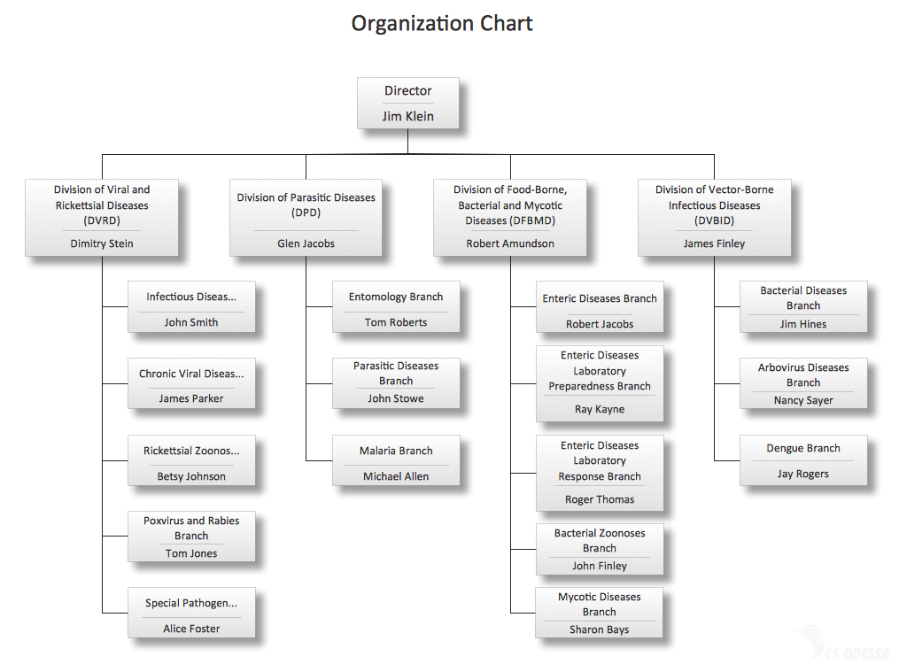

We just acquired a New research company and want them added to the active directory Domains. Please complete this change and send us a memo upon completion.

Note: ONLY ADD THE USERS IN THE DIAGRAM ABOVE.

Note2: YOU MAY SET ALL USERS TO THE SAME DEFAULT PASSWORD

Total time: 30 mins

**Start time: 2:35 pm**

**End time: 3:05 pm**